/** Model 1 =Baseline Model **/

| **Odds Ratio Estimates and Profile-Likelihood Confidence Intervals** | | | | |  |
| --- | --- | --- | --- | --- | --- |
| **Effect** | **Unit** | **Estimate** | **95% Confidence Limits** | | **P value** |
| **age** | **5.0000** | **0.874** | **0.765** | **0.994** | **0.0430** |
| **gender Male vs Female** | **1.0000** | **2.320** | **1.436** | **3.779** | **0.0006** |
| **Nmon (ART Duration by Month)** | **1.0000** | **0.986** | **0.974** | **0.997** | **0.0167** |
| **pay Self Pay + Other vs Family Member/Spouse Pay** | **1.0000** | **0.689** | **0.375** | **1.271** | **0.2306** |
| **faith_act Not Active/No Religion vs Active** | **1.0000** | **1.619** | **1.029** | **2.552** | **0.0371** |
| **family_HIV_bin none vs 1-4** | **1.0000** | **0.680** | **0.424** | **1.086** | **0.1069** |
| **knows_hiv Yes vs No** | **1.0000** | **0.346** | **0.060** | **1.787** | **0.2049** |
| **treat_support Yes vs No** | **1.0000** | **1.836** | **1.001** | **3.393** | **0.0503** |
| **rhiv Who first recommended you to go to an HIV clinic? (Friend vs Family)** | **1.0000** | **0.336** | **0.153** | **0.711** | **0.0028** |
| **rhiv Who first recommended you to go to an HIV clinic? (Other vs Family)** | **1.0000** | **0.350** | **0.173** | **0.695** |
| **rhiv Who first recommended you to go to an HIV clinic? (Provider vs Family)** | **1.0000** | **0.767** | **0.436** | **1.350** |
| **arv_start Sinikithemba (Ridge House) vs Other** | **1.0000** | **0.513** | **0.235** | **1.111** | **0.0897** |
| **arv_train_bin 3+ vs 0-2** | **1.0000** | **0.217** | **0.058** | **0.692** | **0.0143** |
| **current_regimen Other vs D4T** | **1.0000** | **0.482** | **0.276** | **0.836** | **0.0337** |
| **current_regimen ZDV vs D4T** | **1.0000** | **0.681** | **0.335** | **1.373** |
| **CO-TRIMOXAZOLE Yes vs No** | **1.0000** | **1.800** | **1.087** | **2.987** | **0.0223** |
| **FLUCONAZOLE Yes vs No** | **1.0000** | **5.533** | **1.388** | **37.073** | **0.0318** |
| **TBD ETHAMBUTOL Yes vs No** | **1.0000** | **4.707** | **1.068** | **33.382** | **0.0646** |

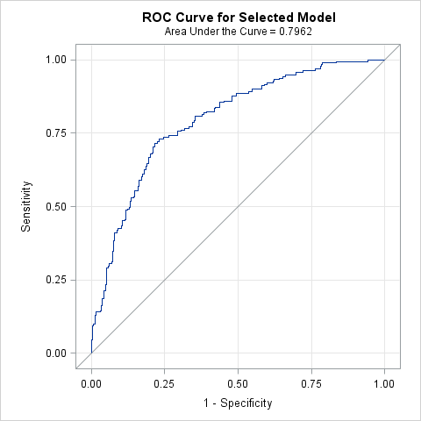

| **Hosmer and Lemeshow Goodness-of-Fit Test** | | |
| --- | --- | --- |
| **Chi-Square** | **DF** | **Pr > ChiSq** |
| 10.0587 | 8 | 0.2609 |

/** Model 2 =Demo + Socieconomic +Psycho + Symptoms + Medical History + Medications, With all suscpted variables*/

| **Odds Ratio Estimates and Profile-Likelihood Confidence Intervals** | | | | |  |
| --- | --- | --- | --- | --- | --- |
| **Effect** | **Unit** | **Estimate** | **95% Confidence Limits** | | **P**  **value** |
| **age** | 5.0000 | 0.846 | 0.728 | 0.980 | 0.0278 |
| **gender Male vs Female** | 1.0000 | 2.423 | 1.365 | 4.351 | 0.0027 |
| **Nmon(ART Duration by Month)** | 1.0000 | 0.990 | 0.977 | 1.004 | 0.1642 |
| **clinic_feel Pleased vs Neutral** | 1.0000 | 0.480 | 0.249 | 0.915 | 0.0263 |
| **practice_safe_bin Often,Sometimes,Rarely,Never vs Always** | 1.0000 | 4.555 | 1.760 | 12.144 | 0.0020 |
| **dep_11(Depression Score) 12+ vs 10 or 11** | 1.0000 | 3.583 | 2.022 | 6.522 | <.0001 |
| **faith_act Not Active/No Religion vs Active** | 1.0000 | 1.708 | 0.998 | 2.932 | 0.0511 |
| **treat_support Yes vs No** | 1.0000 | 1.914 | 0.909 | 4.046 | 0.0871 |
| **knows_hiv Yes vs No** | 1.0000 | 0.384 | 0.058 | 2.136 | 0.2845 |
| **symptom_fatigue Patient have symptom=Yes vs No** | 1.0000 | 1.849 | 1.040 | 3.304 | 0.0366 |
| **symptom_skin Patient have symptom=Yes vs No** | 1.0000 | 2.267 | 1.291 | 4.015 | 0.0046 |
| **symptom_diarr Patient have symptom=Yes vs No** | 1.0000 | 3.735 | 1.562 | 9.168 | 0.0034 |
| **log_cd4** | 1.0000 | 0.172 | 0.063 | 0.436 | 0.0004 |
| **aids_condition___6(Cryptococcus) Yes vs No** | 1.0000 | 0.121 | 0.004 | 1.441 | 0.1252 |
| **non_aids_condition5(Lipodystrophy) Yes vs No** | 1.0000 | 0.526 | 0.277 | 0.977 | 0.0448 |
| **ses_num 2-4 vs 0-1** | 1.0000 | 0.341 | 0.132 | 0.846 | 0.0732 |
| **ses_num 5+ vs 0-1** | 1.0000 | 0.404 | 0.139 | 1.130 |
| **FLUCONAZOLE Yes vs No** | 1.0000 | 11.290 | 1.207 | 294.525 | 0.0650 |
| **TBD ETHAMBUTOL Yes vs No** | 1.0000 | 3.550 | 0.688 | 27.335 | 0.1596 |
| **current_regimen Other vs D4T** | 1.0000 | 0.435 | 0.225 | 0.831 | 0.0386 |
| **current_regimen ZDV vs D4T** | 1.0000 | 0.692 | 0.304 | 1.561 |
| **remember_meds___7(TV/Radio) Yes vs No** | 1.0000 | 3.040 | 1.210 | 7.873 | 0.0192 |
| **arv_train_bin 3+ vs 0-2** | 1.0000 | 0.331 | 0.078 | 1.181 | 0.1060 |
| **rhiv Who first recommended you to go to an HIV clinic? (Friend vs Family)** | 1.0000 | 0.281 | 0.112 | 0.675 | 0.0018 |
| **rhiv Who first recommended you to go to an HIV clinic? (Other vs Family)** | 1.0000 | 0.241 | 0.103 | 0.541 |
| **rhiv Who first recommended you to go to an HIV clinic? (Provider vs Family)** | 1.0000 | 0.625 | 0.319 | 1.218 |
| **arv_start Sinikithemba (Ridge House) vs Other** | 1.0000 | 0.531 | 0.212 | 1.324 | 0.1726 |

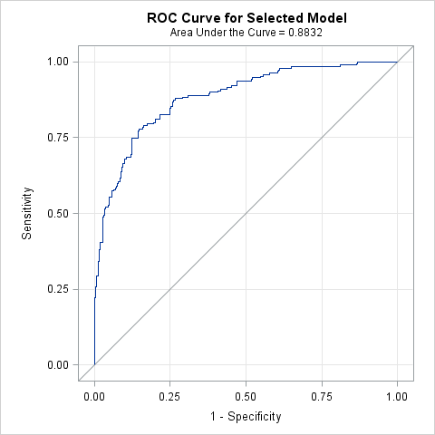

| **Hosmer and Lemeshow Goodness-of-Fit Test** | | |
| --- | --- | --- |
| **Chi-Square** | **DF** | **Pr > ChiSq** |
| 7.4928 | 8 | 0.4845 |

/** Model 3 =Demo + Socieconomic +Psycho + Accesss **/

| **Odds Ratio Estimates and Profile-Likelihood Confidence Intervals** | | | | |  |
| --- | --- | --- | --- | --- | --- |
| **Effect** | **Unit** | **Estimate** | **95% Confidence Limits** | | **P value** |
| **age** | 5.0000 | 0.873 | 0.764 | 0.995 | 0.0440 |
| **gender Male vs Female** | 1.0000 | 2.686 | 1.664 | 4.385 | <.0001 |
| **Nmon(ART Duration by Month)** | 1.0000 | 0.980 | 0.969 | 0.989 | <.0001 |
| **Mpr(Access)** | 0.1000 | 1.008 | 0.839 | 1.203 | 0.9306 |
| **pay Self Pay + Other vs Family Member/Spouse Pay** | 1.0000 | 0.636 | 0.351 | 1.149 | 0.1334 |
| **trans Transport to clinic: (Your car vs All Other)** | 1.0000 | 1.661 | 0.852 | 3.257 | 0.1371 |
| **dep_11 12+ vs 10 or 11** | 1.0000 | 3.013 | 1.862 | 4.952 | <.0001 |
| **faith_act Not Active/No Religion vs Active** | 1.0000 | 1.498 | 0.950 | 2.362 | 0.0813 |
| **knows_hiv Yes vs No** | 1.0000 | 0.246 | 0.046 | 1.135 | 0.0771 |
| **cheer_bin Some,Most,All of the time vs No,A Little of time** | 1.0000 | 2.019 | 0.909 | 4.679 | 0.0906 |
| **practice_safe_bin Often,Sometimes,Rarely,Never vs Always** | 1.0000 | 2.192 | 1.035 | 4.781 | 0.0433 |
| **treat_support Yes vs No** | 1.0000 | 1.734 | 0.948 | 3.207 | 0.0756 |
| **clinic_feel Pleased vs Neutral** | 1.0000 | 0.398 | 0.228 | 0.685 | 0.0010 |

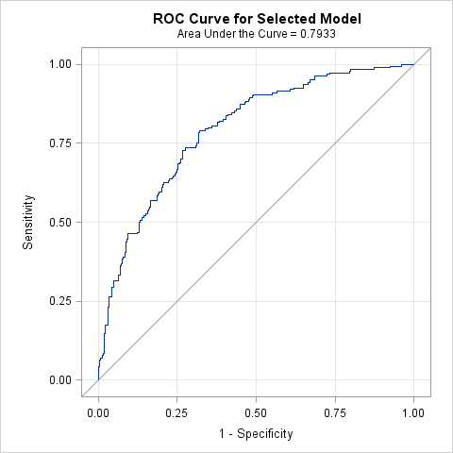

| **Hosmer and Lemeshow Goodness-of-Fit Test** | | |
| --- | --- | --- |
| **Chi-Square** | **DF** | **Pr > ChiSq** |
| 2.6041 | 8 | 0.9567 |

/** Model 4 =Demo + Psycho + Symptoms + Medical History + Medications + Adherence **/

| **Odds Ratio Estimates and Profile-Likelihood Confidence Intervals** | | | | |  |
| --- | --- | --- | --- | --- | --- |
| **Effect** | **Unit** | **Estimate** | **95% Confidence Limits** | | **P value** |
| **age** | **5.0000** | **0.845** | **0.723** | **0.982** | 0.0301 |
| **gender Male vs Female** | **1.0000** | **2.401** | **1.336** | **4.368** | 0.0037 |
| **Nmon (ART by Month)** | **1.0000** | **0.993** | **0.980** | **1.007** | 0.3528 |
| **Pill (Adherence)** | **0.1000** | **0.913** | **0.725** | **1.140** | 0.4249 |
| **dep_11(Depression Score) 12+ vs 10 or 11** | **1.0000** | **3.939** | **2.182** | **7.320** | <.0001 |
| **faith_act Not Active/No Religion vs Active** | **1.0000** | **1.681** | **0.963** | **2.945** | 0.0679 |
| **knows_hiv Yes vs No** | **1.0000** | **0.358** | **0.055** | **1.963** | 0.2455 |
| **practice_safe_bin Often,Sometimes,Rarely,Never vs Always** | **1.0000** | **4.099** | **1.479** | **11.687** | 0.0071 |
| **treat_support Yes vs No** | **1.0000** | **1.770** | **0.841** | **3.727** | 0.1313 |
| **clinic_feel Pleased vs Neutral** | **1.0000** | **0.497** | **0.253** | **0.969** | 0.0409 |
| **symptom_fatigue Patient have symptom=Yes vs No** | **1.0000** | **1.873** | **1.044** | **3.375** | 0.0355 |
| **symptom_diarr Patient have symptom=Yes vs No** | **1.0000** | **3.676** | **1.502** | **9.255** | 0.0048 |
| **symptom_skin Patient have symptom=Yes vs No** | **1.0000** | **2.733** | **1.503** | **5.035** | 0.0011 |
| **symptom_hair Patient have symptom=Yes vs No** | **1.0000** | **0.479** | **0.158** | **1.448** | 0.1897 |
| **log_cd4** | **1.0000** | **0.124** | **0.042** | **0.331** | <.0001 |
| **aids_condition___6(Cryptococcus) Yes vs No** | **1.0000** | **0.110** | **0.004** | **1.392** | 0.1200 |
| **non_aids_condition5(Lipodystrophy) Yes vs No** | **1.0000** | **0.621** | **0.327** | **1.159** | 0.1379 |
| **rhiv Who first recommended you to go to an HIV clinic? (Friend vs Family)** | **1.0000** | **0.262** | **0.101** | **0.643** | 0.0010 |
| **rhiv Who first recommended you to go to an HIV clinic? (Other vs Family)** | **1.0000** | **0.231** | **0.097** | **0.526** |
| **rhiv Who first recommended you to go to an HIV clinic? (Provider vs Family)** | **1.0000** | **0.695** | **0.350** | **1.379** |
| **current_regimen Other vs D4T** | **1.0000** | **0.431** | **0.218** | **0.839** | 0.0339 |
| **current_regimen ZDV vs D4T** | **1.0000** | **0.795** | **0.345** | **1.818** |
| **ses_num 2-4 vs 0-1** | **1.0000** | **0.343** | **0.122** | **0.925** | 0.1143 |
| **ses_num 5+ vs 0-1** | **1.0000** | **0.384** | **0.122** | **1.160** |
| **arv_train_bin 3+ vs 0-2** | **1.0000** | **0.329** | **0.079** | **1.189** | 0.1044 |
| **remember_meds___7(TV/Radio) Yes vs No** | **1.0000** | **2.954** | **1.158** | **7.744** | 0.0247 |
| **FLUCONAZOLE Yes vs No** | **1.0000** | **15.378** | **1.370** | **417.125** | 0.0462 |
| **TBD ETHAMBUTOL Yes vs No** | **1.0000** | **3.202** | **0.591** | **25.232** | 0.2051 |

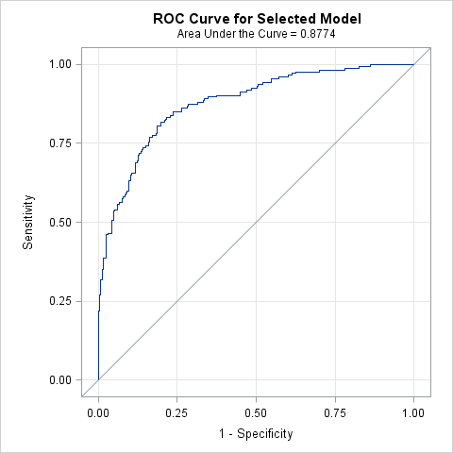

| **Hosmer and Lemeshow Goodness-of-Fit Test** | | |
| --- | --- | --- |
| **Chi-Square** | **DF** | **Pr > ChiSq** |
| 3.2586 | 8 | 0.9171 |

/** Model 5 =Demo + Socieconomic +Psycho + Symptoms + Medical History + Medications + Access + Adherence **/

| **Odds Ratio Estimates and Profile-Likelihood Confidence Intervals** | | | | |  |
| --- | --- | --- | --- | --- | --- |
| **Effect** | **Unit** | **Estimate** | **95% Confidence Limits** | | **P value** |
| **age** | 5.0000 | 0.841 | 0.719 | 0.978 | 0.0264 |
| **gender Male vs Female** | 1.0000 | 2.285 | 1.263 | 4.182 | 0.0067 |
| **nmon** | 1.0000 | 0.994 | 0.980 | 1.008 | 0.3668 |
| **pill** | 0.1000 | 0.910 | 0.721 | 1.136 | 0.4081 |
| **trans Transport to clinic: (choice=Your car vs All Other)** | 1.0000 | 1.584 | 0.671 | 3.754 | 0.2929 |
| **dep_11 12+ vs 10 or 11** | 1.0000 | 4.182 | 2.285 | 7.915 | <.0001 |
| **faith_act Not Active/No Religion vs Active** | 1.0000 | 1.662 | 0.954 | 2.911 | 0.0735 |
| **knows_hiv Yes vs No** | 1.0000 | 0.329 | 0.051 | 1.834 | 0.2117 |
| **practice_safe_bin Often,Sometimes,Rarely,Never vs Always** | 1.0000 | 3.916 | 1.411 | 11.174 | 0.0093 |
| **treat_support Yes vs No** | 1.0000 | 1.850 | 0.871 | 3.943 | 0.1088 |
| **clinic_feel Pleased vs Neutral** | 1.0000 | 0.513 | 0.260 | 1.004 | 0.0520 |
| **symptom_fatigue Patient have symptom=Yes vs No** | 1.0000 | 1.883 | 1.048 | 3.399 | 0.0346 |
| **symptom_diarr Patient have symptom=Yes vs No** | 1.0000 | 3.618 | 1.484 | 9.087 | 0.0052 |
| **symptom_skin Patient have symptom=Yes vs No** | 1.0000 | 2.795 | 1.532 | 5.173 | 0.0009 |
| **symptom_hair Patient have symptom=Yes vs No** | 1.0000 | 0.487 | 0.160 | 1.475 | 0.2002 |
| **log_cd4** | 1.0000 | 0.126 | 0.043 | 0.341 | <.0001 |
| **aids_condition___6(Cryptococcus) Yes vs No** | 1.0000 | 0.115 | 0.004 | 1.470 | 0.1302 |
| **non_aids_condition5(Lipodystrophy) Yes vs No** | 1.0000 | 0.611 | 0.321 | 1.142 | 0.1261 |
| **rhiv Who first recommended you to go to an HIV clinic? (Friend vs Family)** | 1.0000 | 0.264 | 0.102 | 0.652 | 0.0012 |
| **rhiv Who first recommended you to go to an HIV clinic? (Other vs Family)** | 1.0000 | 0.234 | 0.099 | 0.534 |
| **rhiv Who first recommended you to go to an HIV clinic? (Provider vs Family)** | 1.0000 | 0.689 | 0.347 | 1.367 |
| **current_regimen Other vs D4T** | 1.0000 | 0.418 | 0.212 | 0.815 | 0.0258 |
| **current_regimen ZDV vs D4T** | 1.0000 | 0.813 | 0.352 | 1.867 |
| **ses_num 2-4 vs 0-1** | 1.0000 | 0.362 | 0.128 | 0.981 | 0.1438 |
| **ses_num 5+ vs 0-1** | 1.0000 | 0.399 | 0.127 | 1.209 |
| **arv_train_bin 3+ vs 0-2** | 1.0000 | 0.364 | 0.088 | 1.292 | 0.1346 |
| **remember_meds___7(TV/Radio) Yes vs No** | 1.0000 | 3.114 | 1.213 | 8.228 | 0.0193 |
| **FLUCONAZOLE Yes vs No** | 1.0000 | 15.902 | 1.399 | 430.198 | 0.0440 |
| **TBD ETHAMBUTOL Yes vs No** | 1.0000 | 3.492 | 0.639 | 27.648 | 0.1750 |

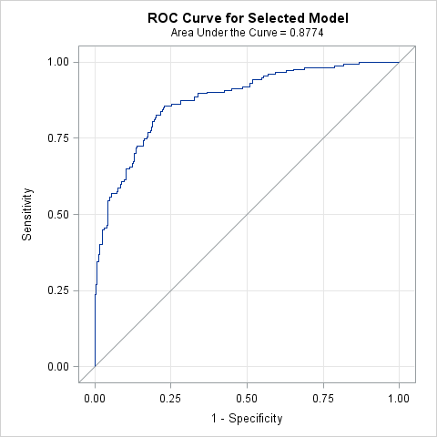

| **Hosmer and Lemeshow Goodness-of-Fit Test** | | |
| --- | --- | --- |
| **Chi-Square** | **DF** | **Pr > ChiSq** |
| 4.2766 | 8 | 0.8313 |